INDEX

Animated Transitions:
# Here’s the model:

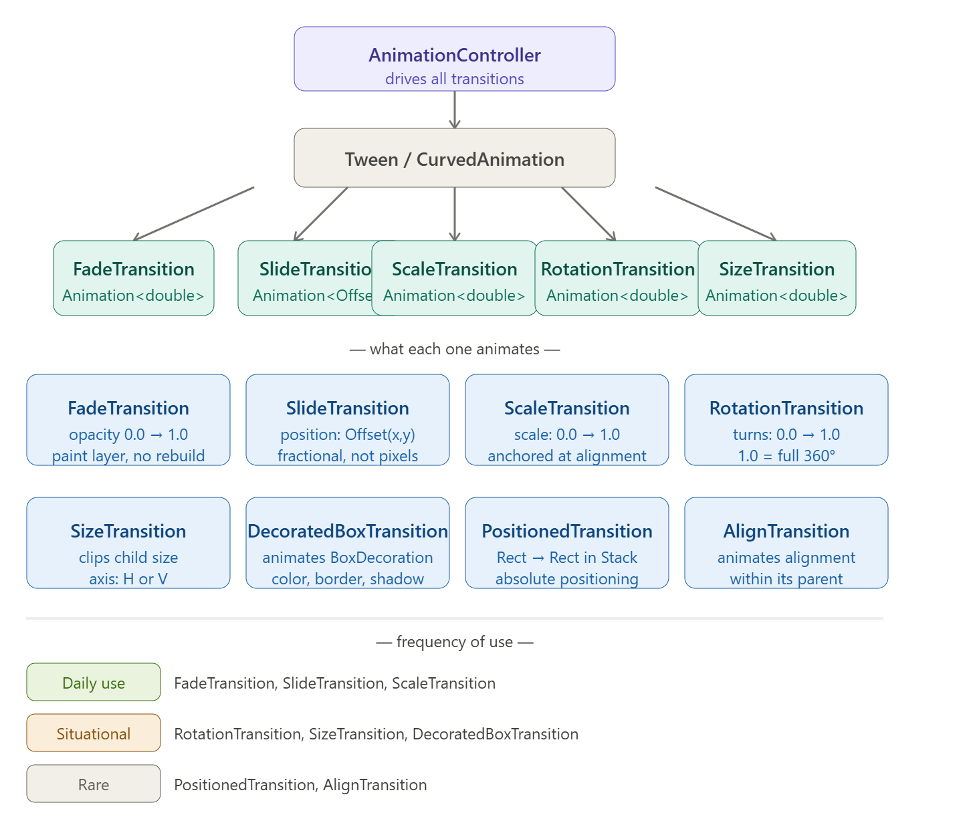
# When to use what:
User taps a button → element fades in? → FadeTransition
Screen pushes in from the side? → SlideTransition
Logo pops in / bounces in? → ScaleTransition + elasticOut
Loading spinner? → RotationTransition
Accordion / expandable panel? → SizeTransition
Card changes color / shape over time? → DecoratedBoxTransition
Element moves between two absolute positions? → PositionedTransition (inside Stack)

FadeTransition Widget (With Fade Animation):
# AnimationController drives values from 0.0 → 1.0 (from the give time in duration: property). FadeTransition is a pre-built widget that listens to an Animation<double> and maps that value directly to widget opacity.
# AnimatedBuilder rebuilds entire subtree on every tick (performance hungry) while FadeTransition internally uses Opacity + listens at the render layer and only repaints opacity composite layer, not the full widget tree

How the Animation Pipeline Works:
# The mental model:
AnimationController → CurvedAnimation → FadeTransition
(0.0 to 1.0, 1s) (applies easeIn) (maps to opacity)
drives shapes consumes

Basic:
# First declare AnimationController and assign it initState. Same thing for Animation<T>, initialize it with CurvedAnimation() in initState
# In CurvedAnimation(), parent: takes the animation controller and curve: takes Curves.easeIn to reshape the animation (like slow start, fast end)
# _animationController.forward() plays the animation once
# Then assign _fadeTransition to opacity property of the FadeTranstion() widget
class _SplashScreenState extends State<SplashScreen> with SingleTickerProviderStateMixin {
late final AnimationController _animationController;
late Animation<double> _fadeAnimation;
@override
void initState() {
super.initState();
_animationController = AnimationController(vsync: this, duration: Duration(seconds: 1));
_scaleAnimation = Tween<double>(begin: 0.3, end: 1.0).animate(
CurvedAnimation(
parent: _animationController,
curve: Curves.easeIn, // ← the fade in magic
),
);
_animationController.forward();
…
}
@override
void dispose() {
_animationController.dispose();
super.dispose();
}
…
Widget build(BuildContext context) {
…
body: FadeTransition(
opacity: _fadeAnimation,
child: Center(…)
…

Common Mistakes:
# Mistake-1, Forgetting to dispose the AnimationController.
# Mistake-2, Using Curves.elasticOut on fade because elastic curve overshoots past 1.0, which on opacity gives opacity > 1.0 and Flutter clamps it but it looks wrong. Only use elastic on scale/position, not opacity.

Tween<double>() method:
# Tween<double>() method maps the AnimationController's 0.0 → 1.0 into any range we want like
- controller at 0.0 → animation outputs 0.3
- controller at 1.0 → animation outputs 1.0
- controller at 0.5 → animation outputs 0.65
# This is really useful when we’re using multiple transitions (like first fade and scale transition together). And we want to quickly boost one of animations (scale) effects than the other one (fade)
# .animate() method takes CurvedAnimtion() which reshapes our animation like for Curves.easeIn (start slow, fast end)
…
_scaleAnimation = Tween<double>(begin: 0.3, end: 1.0).animate(
CurvedAnimation(
parent: _animationController,
curve: Curves.elasticOut, // ← the bounce magic
),
);
_fadeAnimation = Tween<double>(begin: 0.0, end: 1.0).animate(
CurvedAnimation(
parent: _animationController,
curve: const Interval(0.0, 0.4, curve: Curves.easeIn),
),
);

Interval() method:
# Interval() method lets us schedule animations within a portion of the total duration. This lets ONE AnimationController drive multiple animations with different timing (the professional pattern).
# Its curve: property takes a Curves.easeIn (for reshaping the animation like start slow, fast end)
# If its range is 0.0 0.4 which means only run during the first 40% of total animation time (specified in AnimationController which also drives it). After 40%, it stays at its end value (1.0)
# Really useful when are using multiple transitions (like fade and scale transition). And we want one animation (fade) to end quickly than the other one (scale)
…
_scaleAnimation = Tween<double>(begin: 0.3, end: 1.0).animate(
CurvedAnimation(
parent: _animationController,
curve: Curves.elasticOut, // ← the bounce magic
),
);
_fadeAnimation = Tween<double>(begin: 0.0, end: 1.0).animate(
CurvedAnimation(
parent: _animationController,
curve: const Interval(0.0, 0.4, curve: Curves.easeIn),
),
);
# The Interval Mental Model:
Interval(0.0, 0.5, curve: Curves.easeIn)
Total duration = 800ms
0.0 = 0ms (fade starts here)
0.5 = 400ms (fade finishes here, fully opaque)
0.5→1.0 (fade does nothing — already at 1.0)
# If we ever want the fade to start later (like after the slide begins)
//Fade starts at 30% of duration, ends at 80%
Interval(0.3, 0.8, curve: Curves.easeIn)
# One controller. we schedule what happens when, using Interval. This is how production-grade Flutter animations are built.

Curve Cheat Sheet:
# Table:
Curve | Effect | Use for
Curves.easeIn | Slow start → fast end | Exits, fades out
Curves.easeOut | Fast start → slow end | Enters, fades in
Curves.elasticOut | Overshoots, bounces back | Logo pop-in, button press
Curves.bounceOut | Hard physical bounce | Game-like elements
Curves.fastOutSlowIn | Material standard | Most UI transitions

ScaleTransition Widget (Scale Animtion):
# ScaleTransition does the exact same thing as FadeTransition widget but for scaling and has scale: property that takes Animation<double>. It maps the AnimationController (specified in the duration:) value to a scale transform instead of opacity.

How the Animation Pipeline Works:
# The mental model:
AnimationController → CurvedAnimation → ScaleTransition
(0.0 to 1.0, 1s) (applies elasticOut) (maps to opacity)
drives shapes consumes

Basic:
# Declare and initialize AnimationController and Animation<T> in initState
# Assign CurvedAnimation() to _scaleAnimation and then assign it to ScaleTransition() widget
# Curves.elasticOut is the bounce curve. It overshoots past 1.0 (scale momentarily becomes ~1.15), then oscillates back to 1.0. The spring physics are baked in. It reshapes the animation like start oversize, end stabilizing (original size)
# _animationController.forward() plays the animation once
class _SplashScreenState extends State<SplashScreen> with SingleTickerProviderStateMixin {
late final AnimationController _animationController;
late Animation<double> _scaleAnimation;
@override
void initState() {
super.initState();
_animationController = AnimationController(vsync: this, duration: Duration(seconds: 1));
_scaleAnimation = CurvedAnimation(
parent: _animationController,
curve: Curves.elasticOut, // ← the bounce magic
);
_animationController.forward();
…
}
@override
void dispose() {
_animationController.dispose();
super.dispose();
}
…
Widget build(BuildContext context) {
…
body: ScaleTransition(
scale: _scaleAnimation,
child: Center(…)

ScaleTransition with FadeTransition:
# Using Tween<T>() and Interval() method to fit two animations into one AnimationController timing
class _SplashScreenState extends State<SplashScreen>
with SingleTickerProviderStateMixin {
late final AnimationController _animationController;
late final Animation<double> _scaleAnimation;
late final Animation<double> _fadeAnimation;
@override
void initState() {
super.initState();
_animationController = AnimationController(
vsync: this,
duration: const Duration(milliseconds: 900),
);
// Scale: grows from 0.3 → 1.0 with elastic bounce
// Tween maps the 0→1 controller output to 0.3→1.0 range
_scaleAnimation = Tween<double>(begin: 0.3, end: 1.0).animate(
CurvedAnimation(
parent: _animationController,
curve: Curves.elasticOut, // ← the bounce magic
),
);
// Fade: 0→1 but only during the FIRST 40% of the animation
// Interval(0.0, 0.4) means: be done fading by 40% of total duration
_fadeAnimation = Tween<double>(begin: 0.0, end: 1.0).animate(
CurvedAnimation(
parent: _animationController,
curve: const Interval(0.0, 0.4, curve: Curves.easeIn),
),
);
_animationController.forward();
…
}
@override
void dispose() {
_animationController.dispose();
super.dispose();
}
@override
Widget build(BuildContext context) {
return Scaffold(
backgroundColor: AppColors.primary,
body: Center(
// FadeTransition wraps ScaleTransition order matters
// Fade handles opacity, Scale handles size transform
child: FadeTransition(
opacity: _fadeAnimation,
child: ScaleTransition(
scale: _scaleAnimation,
child: Image.asset(…)

Common Mistakes:
# . Nesting ScaleTransition → FadeTransition (wrong order):
// Wrong if Scale is outer then transparent fade area still occupies space and scales
ScaleTransition(
scale: _scaleAnimation,
child: FadeTransition(opacity: _fadeAnimation, child: logo),
)
// Correct Fade outer then widget fades in while also scaling, cleaner visual
FadeTransition(
opacity: _fadeAnimation,
child: ScaleTransition(scale: _scaleAnimation, child: logo),
)

SlideTransition Widget (Slide Animation):
# FadeTransition maps a double to opacity. SlideTransition maps a double to a 2D position offset. But it consumes Animation<Offset> instead of Animation<double>.
# The Offset here is not pixels. It is fractional units relative to the widget's own size. This is the #1 thing people get wrong. Like:
- Offset(0.0, 0.0) → widget at its normal position (no movement)
- Offset(1.0, 0.0) → widget shifted RIGHT by 100% of its own width
- Offset(-1.0, 0.0) → widget shifted LEFT by 100% of its own width
- Offset(0.0, 1.0) → widget shifted DOWN by 100% of its own height
- Offset(0.0, -1.0) → widget shifted UP by 100% of its own height
# So if our logo is 200×200px and we use Offset(0.0, -1.0), it shifts up exactly 200px, its own full height. This is why SlideTransition works at any screen size without hardcoding pixel values.

The Mental Model:
# The Tween<Offset>() interpolates between two Offset values. At controller value 0.5, the offset is exactly halfway between begin and end.
AnimationController (0.0 → 1.0)
↓
Tween<Offset>(
begin: Offset(0.0, -1.0), ← starts above screen
end: Offset(0.0, 0.0), ← lands at normal position
)
↓
CurvedAnimation (shapes timing)
↓
SlideTransition (consumes Animation<Offset>)
↓
Widget slides from top → normal position

Basic Code:
# Everything is same as above. Curves.easeout reshapes the animation (start fast but end slow so decelerates as it lands and feels natural)
class _SplashScreenState extends State<SplashScreen>
with SingleTickerProviderStateMixin {
late final AnimationController _controller;
late final Animation<Offset> _slideAnimation;
@override
void initState() {
super.initState();
_controller = AnimationController(
vsync: this,
duration: const Duration(milliseconds: 800),
);
// Tween<Offset> interpolates between two Offset values
// begin: starts ABOVE the screen (y = -1.0 = one full height above)
// end: lands at normal position (0, 0)
_slideAnimation = Tween<Offset>(
begin: const Offset(0.0, -1.0), // slides from top
end: Offset.zero, // Offset(0.0, 0.0) shorthand
).animate(
CurvedAnimation(
parent: _controller,
curve: Curves.easeOut, // decelerates as it lands, feels natural
),
);
_controller.forward();
}
@override
void dispose() {
_controller.dispose();
super.dispose();
}
Widget build(BuildContext context) {
…
child: SlideTransition(
position: _slideAnimation, // takes Animation<Offset>, NOT Animation<double>
child: Image.asset(…),
}

Direction Reference Table:
# All examples, begin → end (widget travels from begin position to end position)
- Slide from top (falls down):
Tween<Offset>(begin: Offset(0.0, -1.0), end: Offset.zero)
- Slide from bottom (rises up):
Tween<Offset>(begin: Offset(0.0, 1.0), end: Offset.zero)
- Slide from left (enters right)
Tween<Offset>(begin: Offset(-1.0, 0.0), end: Offset.zero)
- Slide from right (enters left)
Tween<Offset>(begin: Offset(1.0, 0.0), end: Offset.zero)
- Diagonal slide (top-left corner)
Tween<Offset>(begin: Offset(-1.0, -1.0), end: Offset.zero)

Slide with Fade Transition:
# One AnimationController. Two animations. Timed differently using Interval so they feel layered, not simultaneous.
Timeline (0ms → 800ms):
Fade: [====40%====]........................ (0% → 40% of duration)
Slide: [================100%================] (0% → 100% of duration)
# So, fade completes quickly, slide decelerates and lands after. This is the professional pattern one controller, multiple intervals.

Full Code:
# Example
class _SplashScreenState extends State<SplashScreen>
with SingleTickerProviderStateMixin {
late final AnimationController _controller;
late final Animation<Offset> _slideAnimation;
late final Animation<double> _fadeAnimation;
@override
void initState() {
super.initState();
_controller = AnimationController(
vsync: this,
duration: const Duration(milliseconds: 800),
);
// Slide: runs the full 800ms, decelerates as it lands
_slideAnimation = Tween<Offset>(
begin: const Offset(0.0, -0.3), // starts just slightly above (30% of height)
end: Offset.zero,
).animate(
CurvedAnimation(
parent: _controller,
curve: Curves.easeOut,
),
);
// Fade: only runs during the first 50% of the 800ms (0ms → 400ms)
// After 400ms it's fully opaque and stays there while slide continues
_fadeAnimation = Tween<double>(
begin: 0.0,
end: 1.0,
).animate(
CurvedAnimation(
parent: _controller,
curve: const Interval(
0.0, // start at 0% of total duration
0.5, // finish at 50% of total duration
curve: Curves.easeIn,
),
),
);
_controller.forward();
}
@override
void dispose() {
_controller.dispose();
super.dispose();
}
Widget build(BuildContext context) {
…
// Order: FadeTransition (outer) → SlideTransition (inner)
// Fade controls visibility, Slide controls position
child: FadeTransition(
opacity: _fadeAnimation,
child: SlideTransition(
position: _slideAnimation,
child: Image.asset(…)
}

Tweak Reference:
What we want | What to change
Longer animation | duration: Duration(milliseconds: 1200)
More dramatic entry | begin: Offset(0.0, -0.6)
Slide from left instead | begin: Offset(-0.4, 0.0)
Fade takes longer | Interval(0.0, 0.8, ...)
Fade starts later | Interval(0.3, 1.0, ...)
Snappier deceleration | curve: Curves.fastOutSlowIn

RotateTransition Widget (with Rotate Animation):
# RotationTransition widget takes turns, where 1.0 = one full 360° rotation. It's not degrees, it's turns
# CurvedAnimation() is not necessary but can be used too
…
_rotationAnimation = Tween<double>(
begin: 0.0, // 0 turns = 0°
end: 1.0, // 1 turn = 360°
).animate(_controller);
…
RotationTransition(
turns: _rotationAnimation,
child: Icon(Icons.refresh),
)

PositionTransition Widget:
#

DecoratedBoxTransition Widget:
# DecoratedBoxTransition animates between two BoxDecoration values so we can smoothly transition colors, border radius, shadows, and borders all at once:
…
_decorationAnimation = DecorationTween(
begin: BoxDecoration(color: Colors.blue, borderRadius: BorderRadius.circular(8)),
end: BoxDecoration(color: Colors.red, borderRadius: BorderRadius.circular(40)),
).animate(_controller);
DecoratedBoxTransition(
decoration: _decorationAnimation,
child: myWidget,
)

SizeTransition Widget:
# SizeTransition clips the widget rather than transforming it, it reveals from 0% to 100% of its size along one axis. Think of it like a curtain pulling open.
# But its not the same as ScaleTransition. ScaleTransition Transforms visually, like a zoom (Space stays the same, widget scales visually) while SizeTransition actually changes layout size (Space shrinks and grows with the widget)
…
SizeTransition(
sizeFactor: _animation, // Animation<double>
axis: Axis.vertical, // or Axis.horizontal
axisAlignment: -1.0, // -1 = expand from top, 0 = center, 1 = bottom
child: myWidget,
)

